1. Open Keynote:
Go to Finder (bottom left) / type Keynote in search box to open the program.
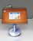

2. Choose your Theme for the presentation. (I chose White)
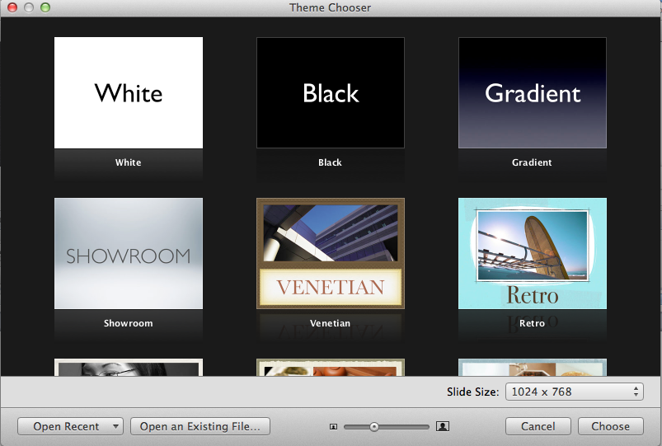

3. Go to Masters icon at the top left (in blue). You may want to set as blank.

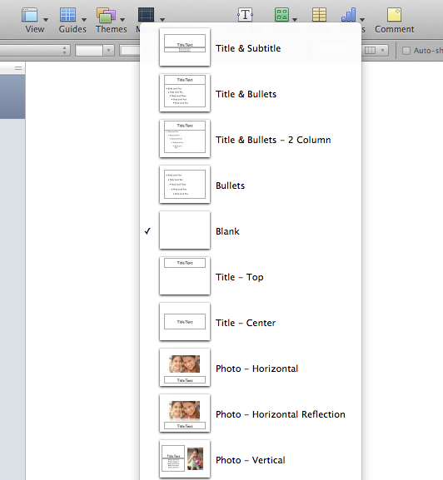

4. Now you are ready to insert your text and pictures.
INSERT TEXT: Go to Insert and click Text Box. Copy and Paste your text from your Word Document.

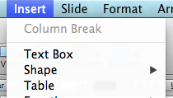

INSERT PICTURE: Go to Insert and Choose. Look for the file on your usb. Then choose the file.
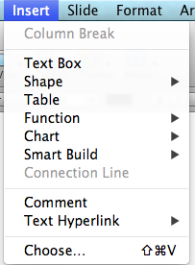

5. To add the other slides, just repeat the process. In order to add more slides: Go to New (top left) and click it for each new slide necessary.

6. Last Step: Record your story. If in partners, make sure that each person has an equal amount of recording (ie. 5 slides each)
Steps: Go to Play and click Record Slideshow.

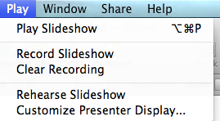
A box will appear with a red button. Now you can start speaking. When you are ready to move to the next slide – hit RETURN on the keyboard.

Note: If you need to record again – click Clear Recording and simply follow the directions again to record.

IMPORTANT: REMEMBER TO NOT READ TOO FAST – Speak Slowly –

At the end, you may listen and view your slideshow by going to Play and then Play Slideshow.

Be sure to save your Slideshow on your USB.

