- Log on
- Go to Start button . In search box, type Sound Recorder. Then, click on Sound Recorder in the search results.

- Click Start Recording. You will now speak and record.

- To stop recording, click Stop Recording.

- You will now have the option to SAVE the recording.

- Save the file as your first and last name. ie. MichaelJordan

- Open your school Gmail and attach your file to an email. To attach a file click on the paper clip.

- Find your file. Click on the file. Click on Open.

- Type in my email address: gleasond@sbregional.org and type your first and last name Recording in the Subject Line. Click send.
Ie. Michael Jordan recording

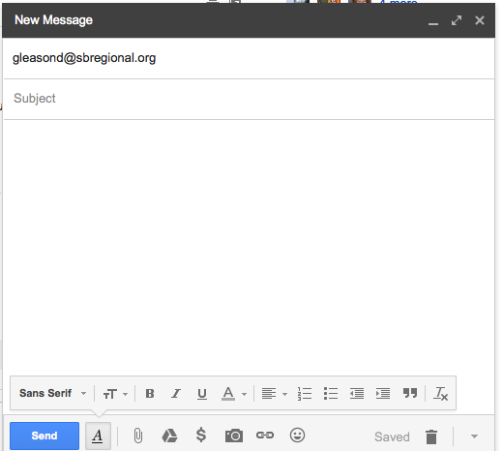

Gracias a Sra. Ponte-Porto por las direcciones.

